Call Type- Pediatric head injury (3 months)

Dispatched as- Woman crying hysterically

Scene Factors- The patients mother comes running down the stairs holding her screaming.

Family’s Story- The mother placed the baby down for a nap and left the room. She came back and hour later to check on the baby and found the baby unresponsive, face down on the floor. No problems with the baby. Other young kids in the house.

Patient story- Patient is unresponsive.

Hx- None

Mx- None

Ax- None

Oriented- Unresponsive

Vital signs-
#1-Initial- HR- 80, NIBP- N/A , RR-20 irregular , O2 Sat-76 %, GCS- 3, Pain- N/A

W/O treatment
#2-HR-60, NIBP-N/A, RR- 10 irregular, O2 Sat-78%, GCS-3, Pain- N/A
#3- HR-104, NIBP-N/A, RR- 15 irregular, O2 Sat- 76%, GCS-3, Pain- N/A

W/ BVM
#2-HR-120, NIBP- N/A, RR-Assisted, O2 Sat-92%, GCS-3, Pain- N/A
#3- HR-160, NIBP-N/A, RR-Assisted, O2 Sat-94%, GCS- 3, Pain- N/A

Head to toe assessment-
Head- Bulging fontanel
Pupils- Left eye 5mm Non reactive, Right eye 2mm Non reactive
Neck- Negative JVD, Negative tracheal deviation.
Chest- Equal chest rise bilaterally
Lung sounds- Clear bilaterally in apex and bases
Back- No deformities noted. Various abrasions noted.
ABD- Soft, Non- tender
Pelvis- Stable
Extremities- Circulation intact. No movement with stimulation.
Skin- Warm, dry, slightly cyanotic

Neuro-
Cincinnati- Unable to perform

Notes-
____________________________________________________________________________________________________________________________________________________________________________________________________________________________________________________________________________________________________________________________________________________________________________________________________________________________________________________________________________________________________________________________________________________________________________________________________________________________________________________________________________________________________________________________________________________________________________________________________________

Background Information for Examiner

6 m/o male patient who is found unresponsive by mother. Pt has bulging fontanel and unequal pupils found on physical exam.

Pt will have a tonic clonic seizure lasting until appropriate anti-convulsant dose is given. Seizure starts just after initial vital signs are taken.

2nd seizure will occur during transport and will continue until repeat dose of anti-convulsant is given.

If no seizure is managed with appropriate dose of versed or within 1 minute then the pt will go into cardiac arrest.

An appropriate call ahead and destination choice of SMH needs to be made while en-route.

Call Type- Pediatric Seizure (6 months)

Dispatched as- child unresponsive

Scene Factors- The patients mother comes running down the stairs holding her child.

Family’s Story- The mother placed the child down for a nap and left the room. She came back an hour later to check on the baby and found the child unresponsive, face down on the floor. There are other young kids in the house.

Patient story- Patient is unresponsive.

Hx- None

Mx- None

Ax- None

Oriented- Unresponsive

Vital signs-
#1-Initial- HR- 188, NIBP- N/A , RR-34 irregular , O2 Sat-76 %, GCS- 3, Pain- N/A

W/O treatment of seizure and ventilation
#2 -HR-58, NIBP-N/A, RR- 6 irregular, O2 Sat- 76%, GCS-3, Pain- N/A
#3 – HR-0, NIBP-0, RR-0, O2Sat – 50%, GCS – 3, Pain -N/A -> Asystole arrest, no intervention causes improvement.

1st Seizure W/ BVM and Versed
#2-HR-120, NIBP- N/A, RR-Assisted, O2 Sat-96%, GCS-3, Pain- N/A

2nd Seizure W/ BVM and Versed
#3 - HR-136, NIBP- N/A, RR-Assisted, O2 Sat-94%, GCS-3, Pain- N/A

Head to toe assessment-
Head- Bulging fontanel
Pupils- Left eye 5mm Non reactive, Right eye 3mm Sluggish
Neck- Negative JVD, Negative tracheal deviation.
Chest- Equal chest rise bilaterally
Lung sounds- Clear bilaterally in apex and bases
Back- No deformities noted. Various abrasions noted.
ABD- Soft, Non- tender
Pelvis- Stable
Extremities- Circulation intact. No movement with stimulation.
Skin- Warm, dry, slightly cyanotic

Neuro-
Cincinnati- Unable to perform

Notes-
____________________________________________________________________________________________________________________________________________________________________________________________________________________________________________________________________________________________________________________________________________________________________________________________________________________________________________________________________________________________________________________________________________________________________________________________________________________________________________________________________________________________________________________________________________________________________________________________________________

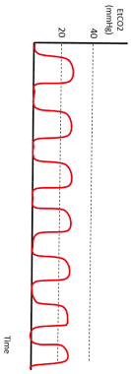
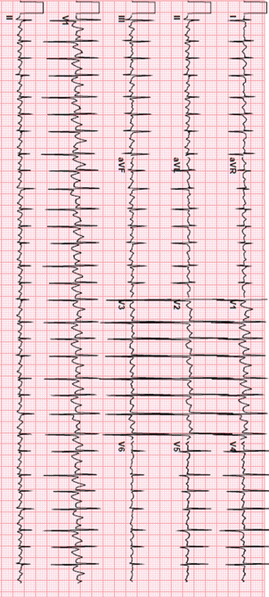

Background Information for the examiner:

Patient has been experiencing an increase in cold-like-symptoms. Patient is now presenting with signs of Croup. Mother is young and frantic. Initial treatment including nothing. Mother begins to cry when loading the patient into the ambulance, which causes the patient to become upset. The patient quickly deteriorates due to the airway aggravation. If the mother is not calmed down, the patient will die. EMS has a small window of opportunity to calm the mother and begin administering racemic epinephrine.

EKG: Sinus Tachycardia

Call Type- Pediatric Croup

Dispatched as- Child trouble breathing

Scene Factors- Young adult mother is franticly crying

Family’s Story- After a long and cold winter, spring weather finally hit. Mother took her children to the park over the weekend while it was 68 degrees and sunny. Since then, the patient has had a dry cough and runny nose.

Patient Presentation – Patient is found in bed, sitting upright, and leaning against the wall. Patient does not respond to ems entering the room. Appears to be breathing heavily with audible stridor noted.

During transport – patient begins to cry which upsets the mother. Crying induces a barking cough, decreased LOC and drooling. Humidified oxygen is acceptable, IF the mother and patient are not kept calm, the patient rapidly deteriorates to nearly unresponsive.

Hx- None

Mx- Tylenol as needed

Ax- None

Oriented- uninterested in surroundings and does not react to ems presence.

Vital signs-
#1-Initial- HR- 120, NIBP- 86/54, RR- 30 irregular, O2 Sat- 92%, GCS- 13, Pain- N/A

W/O treatment (calming the mother and patient)
#2-HR- 154, NIBP-92/62, RR- 38 irregular, O2 Sat- 88 %, GCS-13, Pain- N/A
#3- HR- 68, NIBP-82/50, RR- 12 irregular, O2 Sat- 58 %, GCS-3, Pain- N/A

W/ Racemic Epinephrine
#2-HR-132, NIBP- 96/68, RR-28, O2 Sat-92%, GCS-15, Pain- N/A
#3- HR-112, NIBP-94/62, RR-26, O2 Sat-94%, GCS- 15, Pain- N/A

Head to toe assessment-
Head- Normal
Pupils- PERRL
Neck- Negative JVD, Negative tracheal deviation.
Chest- Equal chest rise bilaterally
Lung sounds- wheezing upper, diminished lowers
Back- No deformities noted.
ABD- Soft, Non- tender
Pelvis- Stable
Extremities- Circulation intact. No movement with stimulation.
Skin- Hot, dry, pale

Neuro-
Cincinnati- Unable to perform

Notes-
____________________________________________________________________________________________________________________________________________________________________________________________________________________________________________________________________________________________________________________________________________________________________________________________________________________________________________________________________________________________________________________________________________________________________________________________________________________________________________________________________________________________________________________________________________________________________________________________________________

