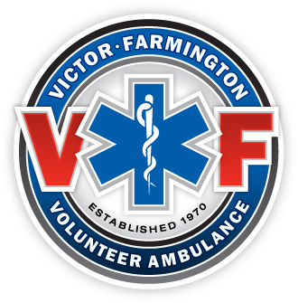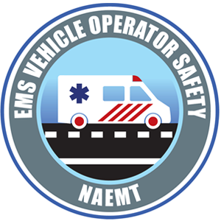
Training Announcement

May 14th 2026
1200-1600
Emergency Vehicle Operator Safety
VF Training Room
Join us on the above date in the training room for an NAEMT Emergency Vehicle Operator Safety course. Please contact Rob Merkel via email at rmerkel@victorfarmingtonambulance.org with questions or to sign up!
NAEMT's EMS Vehicle Operator Safety (EVOS) course addresses the knowledge gap that leads to injuries and deaths, and focuses on the specific behaviors that need to be changed to create a culture of safe driving. Drawing on the most current research about the behaviors and other hazards that lead to crashes, EVOS features case studies and analyses of both common and catastrophic collisions. EVOS challenges EMS practitioners to reconsider their preconceptions about safe vehicle operations. Topics covered in the course include:
- Making driving safety a priority
- Legal aspects of EMS vehicle operation
- Maneuvering an EMS vehicle
- Vehicle inspection and maintenance
- Mental, emotional and physical preparedness
- Emergency response
- Crash prevention
- Driving skills
- Technological aids
- Simulation training
EVOS is appropriate for EMS practitioners at all levels. EVOS is accredited by CAPCE and recognized by NREMT. Fee of $75.00 per student applies to non members of Victor Farmington Ambulance.

